**REQUIREMENTS ANALYSIS USING CRITICAL THINKING**

**FUNCTIONAL&OPERATIO0NAL REQUIRMENT**

|  |  |
| --- | --- |
| Date | November 14, 202 |
| Team ID | PNT2022TMID41871 |
| Project Name | Real-Time River Water Quality Monitoring and Control System |
| Maximum Marks | 4 Marks |

**ABSTRACT:**

This project aims to aid the deaf-mute by creation of a new system that helps convert sign language to text and speech for easier communication with audience. The system consists of a gesture recognizer hand-glove which converts gestures into electrical signals using flex sensors. These electrical signals are then processed using an Arduino micro controller and a Python- based back end for text-to-speech conversion. The glove includes two modes of operation – phrase fetch mode and letter fetch mode. The phrase fetch mode speaks out words at once, while the letter fetch mode speaks out individual letters. This project forms a base infrastructure which can later be augmented with addition of different Sign Languages and integrating with other hearing impaired aid systems

**A. HARDWARE COMPONENTS**

# 1. Flex Sensor Flex Sensor

Uses technology which is based on resistive carbon elements. Flex sensor acts as a variable resistor. Flex Sensors achieve a great form-factor on a thin flexible substrate. When a flex sensor is bent, it produces an output resistance corresponding to the bend radius. Smaller the radius, the higher the resistance value

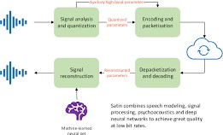

# 2 Resistance Change

Arduino U no is a micro controller based on the ATmega328. It has 14 digital I/O pins, 6 analog inputs pins, a 16 MHz ceramic resonator, a USB connection, a power jack, an ICSP header and a reset button. It can be powered via the USB connection or with an external power supply 5 to 20 volts).

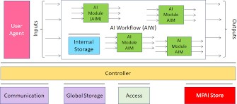

In this mode, as the name suggests, the system prints and speaks out entire words at once. Fig. 7. shows the flowchart for the phrase mode method in the Python program. Each letter transmitted to the computer over serial port is buffered into a character array. Once the system receives EOL character, the buffered string is printed and spoken out using the TTS system. Fig. 7Phrase Mode Subroutine Fig. 8

Letter TTS Subroutine

In Letter Mode, the computer does not buffer characters received at the Serial port, instead prints and

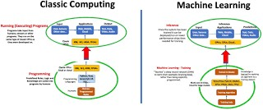

speaks out the letter s as soon as it receives those